**Chapter 4:** **Refraction**

***Please remember to photocopy 4 pages onto one sheet by going A3→A4 and using back to back on the photocopier***

**Something to think about**

“Twinkle twinkle little star . . .”

Why do stars twinkle but not planets?

**Refraction is the bending of a wave as it passes from a medium of one refractive index to another medium of different refractive index.**

When light travels from a medium of ***lower refractive index to a medium of higher*** ***refractive index*** it is refracted ***towards the normal*** and *vice versa\**.

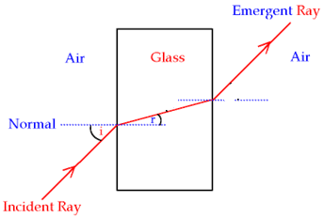

**The two laws of refraction of light**

1. **The incident ray, the normal and the refracted ray all lie on the same plane.**

(not to be confused with the *reflected* ray, from the laws of *reflection* of light).

1. **The ratio of the sin of the angle of incidence to the sin of the angle of refraction is a constant called the refractive index.**

$$R.I.=\frac{sin i}{sin r}$$

The refractiveindex between any two media is a constant and is given the symbol ŋ.

**The second law of refraction is also known as Snell’s law*.**

This leads to the following definition: **The refractive index of a medium** is the ratio of the sine of the angle of incidence to the sine of the angle of refraction *when light travels from a vacuum into that medium*.

(In practice we consider air and a vacuum to be equivalent).

Note that if you see the phrase “the refractive index of glass is 1.5”, it means that “when light travels *from air into glass* the refractive Index is 1.5”.

This is written as aŊg = 1.5

If light is going in the other direction (i.e. from glass to air), the refractive index will be the inverse of 1.5.   
i.e. if aηg = 1.5, then gηa =

**If aηg = 1.5, then gηa =**

See 2012 Question 12 (b) {I think this was the only time it arose, which was very nasty because most people wouldn’t be expecting it}

**Refractive index in terms of the speed of light in different media**

Light travels at different speeds in different media. The relationship between these speeds leads to another formula for the refractive index of a medium:

$$R.I. of medium=\frac{speed of light in air}{speed of light in medium}$$

$$R.I.=\frac{C_{air}}{C_{medium}}$$

**Or**

Note that the speed of light is 3×108 m s-1 (that’s 300 million metres per second, or 300 000 km per second!)

Of all the formulae to do with refractive index, this is the most fundamental in that the reason light refracts in the first place is because it travels at different speeds in the different media.

************* neither of the formulae above are in the log tables ***************

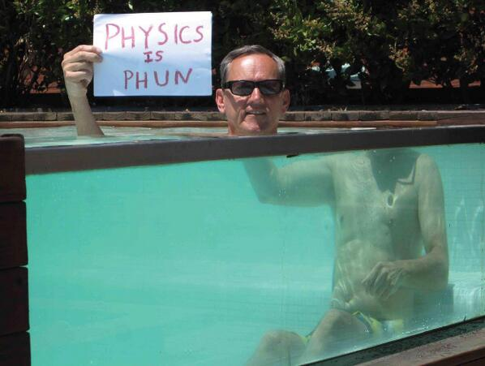

**Refractive Index in terms of Real Depth and Apparent Depth**

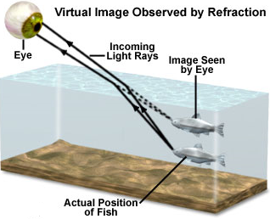Refraction explains why a swimming pool is deeper than it actually appears to be.

$$R.I.of a medium=\frac{Real Depth}{Apparent Depth}$$

***The critical angle* and *total internal reflection***

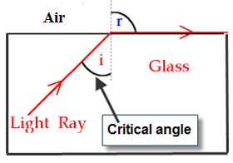

**The critical angle**

Look at the glass block in the diagram.

When the angle of incidence (in the glass block) reaches a certain (critical) angle, the light no longer refracts outward, but instead travels along the surface.

The angle of refraction is now 900, and this leads to a definition of *the critical angle*.

**The critical angle corresponds to the angle of incidence which causes the angle of refraction to be 900**.

**Relationship between Critical Angle and Refractive Index**

$$R.I.of a medium=\frac{1}{sin C}$$

Where *C* represents the critical angle

(If you’re clever you can even show where this formula comes from; the trick is to remember that in general the term *refractive index* refers to light travelling from *air to the medium*, whereas for the critical angle light is travelling from the *medium into air*).

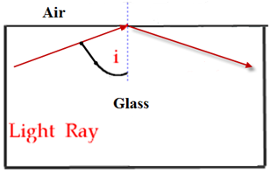

**Total internal reflection**

Now if we increase the angle of incidence beyond the critical angle, the light ray won’t actually leave the block at all, but will ‘reflect’ back as if it was striking the surface of a mirror.   
We say that the light is now ‘totally internally reflected’.

**Total internal reflection** occurs when the angle of incidence is greater than the critical angle and light is reflected back into the denser medium.

*You should be able to demonstrate this in the classroom*

**Using a prism to turn a ray of light through (i) 900 (ii) 1800**

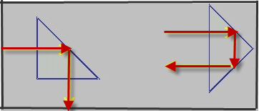

*You should be able to demonstrate this in the classroom*

**Applications of Total Internal Reflection**

1. Optical Fibres
2. Endoscopes
3. Reflective road signs
4. Periscopes

**Optical Fibres\***

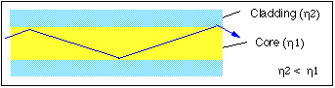

**How light is transmitted in an optical fibre**

1. An optical fibre consists of a glass pipe coated with a second material *of lower refractive index*.
2. Light enters one end of the fibre and strikes the boundary between the two materials *at an angle greater than the critical angle,* resulting in total internal reflection at the interface.
3. This reflected light now strikes the interface on the opposite wall and gets totally reflected again.
4. This process continues all along the glass pipe until the light emerges at the far end.

**Note:**

* If the second cladding material wasn’t there or had a refractive index greater than that of the central core total internal reflection would not occur and the light would simply escape out.
* The outer cladding also acts as a protective layer against scratches etc.
* The word "fiber" comes from the fact that these cables are incredibly thin, about the size of a hair.

**Applications**

* Telecommunications
* Medicine (endoscopes)

**Advantages of optical fibres over copper conductors**

Less interference / cheaper raw material / occupy less space / more information (carried) in the same space / flexible for inaccessible places/ do not corrode

**Summary of Formula**

$R.I.=\frac{sin i}{sin r}$ $R.I.=\frac{Speed of light in air}{Speed of light in medium}$ $R.I.=\frac{1}{sin C}$

$$R.I.=\frac{Real Depth}{Apparent Depth}$$

**If aηg = 1.5, then gηa =**

**Mandatory Experiment:**

**To verify Snell’s Law and use it to measure the refractive index of a solid.**

**Leaving Cert Physics Syllabus: Refraction**

|  |  |  |  |
| --- | --- | --- | --- |
| **Content** | **Depth of Treatment** | **Activities** | **STS** |
|  |  |  |  |
| 1. Laws of refraction | Refractive index  **Refractive index in terms of relative speeds.** | Demonstration using ray box *or* laser *or* other suitable method.  Appropriate calculations.  **Appropriate calculations.** | Practical examples, e.g. real and apparent depth of fish in water. |
|  |  |  |  |
| 2. Total internal reflection | Critical angle  Relationship between critical angle and refractive index.  Transmission of light through optical fibres. | Demonstration.  Appropriate calculations | Reflective road signs.  Mirages.  Prism reflectors.  Uses of optical fibres:   * telecommunications * medicine (endoscopes) |
| Experiments:   1. Verification of Snell’s law of refraction. 2. Measurement of the refractive index of a liquid *or* a solid. | | | |

**VERIFICATION OF SNELL’S LAW OF REFRACTION**

***Or***

**TO MEASURE THE REFRACTIVE INDEX OF A GLASS BLOCK**



**APPARATUS:** Glass block, ray-box, protractor, page

**DIAGRAM** (I couldn’t find one which included the ray-box)

**PROCEDURE**

1. Place a glass block on the page and mark its outline.
2. Shine a ray of light from the ray-box into the glass block.
3. Mark two dots on the incident ray and exit ray and draw the outline of the block.
4. Remove the block and complete all lines including the normal, as indicated on the diagram.
5. Measure the angle of incidence i and angle of refraction r using the protractor.
6. Repeat for different values of i.
7. Draw up a table as shown.
8. Plot a graph of sin i against sin r. A straight line through the origin verifies Snell’s law of refraction

i.e. sin i ∝ sin r.

1. The slope of the line gives a value for the refractive index of glass.
2. The refractive index of glass is also equal to the average value of $\frac{\sin{i}}{\sin{r}}$

**RESULTS**

|  |  |  |  |  |  |  |  |
| --- | --- | --- | --- | --- | --- | --- | --- |
| i (degrees) |  |  |  |  |  |  |  |
| r (degrees |  |  |  |  |  |  |  |
| sin i |  |  |  |  |  |  |  |
| sin r |  |  |  |  |  |  |  |
| $$n= \frac{\sin{i}}{\sin{r}}$$ |  |  |  |  |  |  |  |
| **Average value for refractive index =** | | | | | | | |

**SOURCES OF ERROR / PRECAUTIONS**

1. Using small angles of incidence will result in large percentage errors.
2. Place two dots far apart on the incident and refracted light beams to accurately locate the beams

**Tip when carrying out the experiment**

Start with a small angle of incidence and measure the corresponding angle of refraction.

Now increase this angle at roughly regular intervals each time to ensure a wide range of values (rather than simply taking angles at random each time).

**Common student-errors on tests on this topic**

Keep your test paper and your answer page. Your focus when you go to revise should be on what you got wrong on the test.

Almost all questions are from the test questions which would already have been covered either in class or for homework. That is/should be your essential starting point in identifying what you do or do not know or understand.

**Not learning definitions off by heart** – putting them in your own words is asking for trouble. See the next point.

**Quite often the sentence doesn’t even read as a proper sentence.**

The marking scheme clearly states that all terms must be in the correct context. So if the definition isn’t coherent as a standalone sentence then you can’t get full marks.

So read over it before you move on.

Your calculator must be in ‘Degrees mode’. If you don’t know what that means then find out.

**How does an optical fibre work?**  
You need (at least) three separate points of information (and a diagram is also a good idea).

**Graph/Experiment section**

* It’s *sin i* and *sin r*, not i and r.
* Always label your axes.
* Use a pencil, not a biro.
* Remember the concept of ‘best-fit line’.
* Newsflash: it must be one continuous line.
* Always extend the line back to (or very near to) the origin.
* When finding the slope of the graph, your two points **must be on the line**. Can you say why?
* Indicate clearly which two points you are using.
* When asked ‘how does your graph verify Snell’s Law’? the answer is:   
  “*Because a graph of sin i against sin r resulted in a straight line trough the origin* (which in turn proves that sin i and sin r are proportional to each other, which ultimately is what Snell’s Law is all about).”  
  Note that a straight line through the origin is always how we verify that two variables are proportional to each other.

**Extra Credit**

**\*When light travels from a medium of lower refractive index to a medium of higher refractive index it is refracted towards the normal and vice versa.**  
Density and refractive index are not the same thing.

Many oils for example have a greater refractive index than water but are less dense than water.

There is then the issue of what type of density the definition is referring to; is it mass/volume, is it optical density or is it density of electrons (given that the movement of light is affected by electric fields associated with electrons).

**\*Snell’s Law**

Utterly useless trivia #1: The law of refraction was first accurately described by [Ibn Sahl](http://en.wikipedia.org/wiki/Ibn_Sahl), of Baghdad, in 984.

Utterly useless trivia #2: In French, Snell's Law is called "la loi de Descartes" or "loi de Snell-Descartes" because the French philosopher/mathematician/scientist came up with the law independently in 1637 (Snell devised his version in 1621).

We now come to a *non* useless trivia bit: how does the light *know* how much to bend when it hits the water/air interface (let’s assume it’s going from air to water)? This is a very disconcerting issue – it seems that light follows the path of least time – i.e. it takes the quickest route from A to B, which is obviously a straight line in a given medium, but when it’s passing from one medium to another it bends in such a way that its overall journey-time is a minimum. The physicist Richard Feynman gave the following scenario to explain the concept: a lifeguard on a beach spots a swimmer in trouble some distance away, in a diagonal direction. He can run three times faster than he can swim. What is the quickest path to the swimmer?

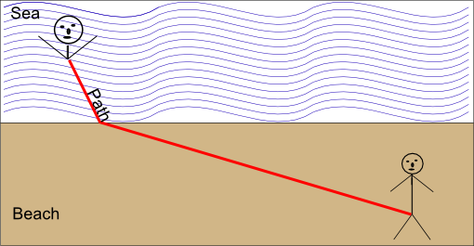

But I ask again – how does light *know* how much to bend by?

See the related link in the refraction page of thephysicsteacher.ie

***\*In other words if you see the phrase “the Refractive Index of glass is 1.5”, it means that when light travels from air into glass the refractive Index is 1.5***

This is important to remember because if light is going in the other direction (i.e. from glass to air, the refractive index will not be 1.5 – it will in fact be 1/15).

This often causes confusion; especially when we go on to define the critical angle.

**Ŋ = c1/c2**

Why is "c" used for the speed of light?

From the Latin 'celeritas', meaning speed, as an alternative to v (for particles).

**\*Optical Fibres**

Irishman John Tyndall - from County Carlow of all places (who would have guessed Carlow would be capable of producing anything useful?) was one of first to investigate fibre optics, and demonstrated it using a water fountain.

Tyndall was one of the foremost scientists in Britain in the mid to late 1800’s and did a lot of pioneering work on optics. He was the first to explain properly why the sky is blue and why it gets red as the sun goes down. He was also a noted mountaineer.

Never again ask why God invented Carlow.

**Experiments**

There are three mandatory experiments on the syllabus to do with refraction

To verify Snell’s Law

To measure the refractive index of a liquid *or* a solid.

The *or* in italics implies that you must be given the option, and therefore the exam question cannot specify measuring the refractive index of a liquid.

But in verifying Snell’s Law, we plot a graph of Sin i against Sin r, and show that because the graph is a straight line going through the origin, the two variables are directly proportional.

To calculate the refractive index we then simply calculate the slope of the graph, and if Sin i is on the y-axis, the slope corresponds to the refractive index.

No need to worry about measuring the refractive index of any messy liquids!

**Exam questions: Refraction**

1. [2010 OL]

Which of these scientists is associated with the law of refraction of light?

Rutherford Snell Joule Einstein

1. [2008][2006][2002 OL][2004 OL][2005 OL][2009 OL]

What is meant by refraction of light?

1. [2008]State Snell’s law of refraction.

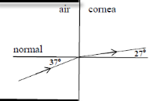

1. [2002][2002 OL]State the laws of refraction of light.
2. [2004 OL]What is meant by the refractive index of a material?
3. [2008]
4. Light is refracted as it travels from air into the cornea as shown in the diagram.

Calculate the refractive index of the cornea.

1. Draw a diagram to show the path of a ray of light if it travelled from water of refractive index 1.33 into the cornea.



1. [2005 OL]
2. What special name is given to the angle of incidence *i*, when the effect shown in the diagram occurs?
3. In the diagram the value of the angle *i* is 41.80. Calculate a value for the refractive index of the glass.
4. Draw a diagram to show what happens to the ray of light when the angle of incidence *i* is increased to 450.
5. [2003 OL] Explain total internal reflection with the aid of a labelled diagram
6. [2004 OL] When will total internal reflection occur?
7. [2004 OL] Define the critical angle.
8. [2003 OL] The critical angle for the glass is 42o. Calculate the refractive index of the glass.
9. [2007] The refractive index of a liquid is 1.35, what is the critical angle of the liquid?
10. [2003] Calculate the critical angle for diamond. The refractive index of diamond is 2.4.
11. [2010] What is the critical angle of a sample of glass whose refractive index is 1.46?
12. [2003 OL]
13. The diagram shows a 45o prism made of glass and a ray of light entering the prism from air. Copy the diagram and show the path of the ray through the prism and back into the air.
14. Explain why the ray follows the path that you have shown.
15. [2003 OL][2005 OL]Give two uses of total internal reflection.

**Optical fibres**

1. [2009 OL]

Draw a diagram to show the path of a ray of light travelling through an optical fibre.

1. [2009][2004][2004 OL]

Explain how a signal is transmitted along an optical fibre.

1. [2004 OL]

How is the escape of light from the sides of an optical fibre prevented?

1. [2004][2009]

An optical fibre has an outer less dense layer of glass. What is the role of this layer of glass?

1. [2004 OL]

Give one use for optical fibres.

1. [2004]

Give two reasons why the telecommunications industry uses optical fibres instead of copper conductors to transmit signals.

1. [2009]

Impurities in glass reduce the power transmitted in an optic fibre by half every 2 km.

The initial power being transmitted by the light is 10 W.

What is the power being transmitted by the light after it has travelled 8 km through the fibre?

1. [2009]

Information is transmitted over long distances using optical fibres with a refractive index of 1.55.

What is the speed of the light as it passes through the fibre?

1. [2004]

An optical fibre is manufactured using glass of refractive index of 1.5.

Calculate the speed of light travelling through the optical fibre.

1. [2004 OL]

Name a material that is used in the manufacture of optical fibres.

**Mandatory Experiments**

1. [2008 OL][2013 OL]

An experiment was carried out to measure the refractive index of a substance.

The experiment was repeated a number of times.

1. Draw a labelled diagram of the apparatus that could be used in this experiment.
2. What measurements were taken during the experiment?
3. How was the refractive index of the substance calculated?
4. Why was the experiment repeated?
5. [2006 OL]

A student carried out an experiment to verify Snell’s law of refraction by measuring the angle of incidence *i* and the angle of refraction *r* for a ray of light entering a glass block. The student repeated this procedure two more times. The data recorded by the student is shown in the table.

|  |  |  |  |  |
| --- | --- | --- | --- | --- |
| angle of incidence i | angle of refraction r | sin i | sin r | sin i/sin r |
| 30o | 19o |  |  |  |
| 45o | 28o |  |  |  |
| 65o | 37o |  |  |  |

1. Draw a labelled diagram of the apparatus used in the experiment.
2. Describe how the student found the position of the refracted ray.
3. How did the student measure the angle of refraction?
4. Copy this table and complete it in your answer-book.
5. Use the data to verify Snell’s law of refraction.
6. [2010]

|  |  |  |  |  |  |  |  |
| --- | --- | --- | --- | --- | --- | --- | --- |
| *i* / ° | 30 | 40 | 50 | 55 | 60 | 65 | 70 |
| *r* / ° | 19 | 26 | 30 | 33 | 36 | 38 | 40 |

In an experiment to verify Snell’s law, a student recorded the following data.

1. Draw a labelled diagram of the apparatus used.

On your diagram, indicate an angle *i* and its corresponding angle *r*.

1. Using the recorded data, draw a suitable graph
2. Explain how your graph verifies Snell’s law.
3. Using your graph, find the refractive index
4. The student did not record any values of *i* below 30°, give two reasons why?
5. [2005]

|  |  |  |  |  |  |  |
| --- | --- | --- | --- | --- | --- | --- |
| *i*/degrees | 20 | 30 | 40 | 50 | 60 | 70 |
| *r*/degrees | 14 | 19 | 26 | 30 | 36 | 40 |

In an experiment to verify Snell’s law, a student measured the angle of incidence *i* and the angle of refraction *r* for a ray of light entering a substance. This was repeated for different values of the angle of incidence. The following data was recorded.

1. Describe, with the aid of a diagram, how the student obtained the angle of refraction.
2. Draw a suitable graph on graph paper and explain how your graph verifies Snell’s law.
3. From your graph, calculate the refractive index of the substance.
4. The smallest angle of incidence chosen was 200.

Why would smaller values lead to a less accurate result?

**Exam solutions: Refraction**

1. Snell
2. Refraction of light is the bending of light as it passes from one medium to another (of different refractive index).
3. The ratio of the sin of the angle of incidence to the sin of the angle of refraction is a constant.
4. The incident ray, the normal and ***the*** ***refracted*** ***ray*** all lie on the same plane.

The ratio of t the sin of the angle of incidence to the sin of the angle of refraction is a constant.

1. n = sin i/ sin r, where i is the angle of incidence and r is the angle of refraction and light is travelling from a vacuum into that medium

⇒ n = sin 37/sin 27  n = 1.33

1. Both media have the same refractive index so there is no bending of light so draw a straight line passing from one medium to the other without bending.
2. 
3. It is called the critical angle.
4. n= 1/ sin C ⇒ n = 1/sin 41.80 ⇒ n = 1/0.67 ⇒ n = 1.5.
5. See diagram.
6. 
7. Total internal reflection occurs when the angle of incidence is greater than the critical angle and light is reflected back into the first medium.
8. When the angle of incidence is greaterthan the critical angle.
9. The critical angle corresponds to the angle of incidence in the denser of two media which causes the angle of refraction to be 900.
10.  n = 1.49
11. C = 47.80
12. 0.417 C = 24.60
13. 0.685 C = 43.20



1. See diagram
2. Because total internal reflection occurs twice while inside the prism.
3. Fibre optics, endoscopes, reflective road signs, telecommunications, binoculars, periscope.
4. 1.35, what is the critical angle of the liquid?
5. [2003]Calculate the critical angle for diamond. The refractive index of diamond is 2.4.
6. [2010] What is the critical angle of a sample of glass whose refractive index is 1.46?

**Optical fibres**

1. Answer:
2. ****An optical fibre consists of a glass pipe coated with a second material of lower refractive index.
3. Light enters one end of the fibre and strikes the boundary between the two materials *at an angle greater than the critical angle,* resulting in total internal reflection at the interface.
4. This reflected light now strikes the interface on the opposite wall and gets totally reflected again.
5. This process continues all along the glass pipe until the light emerges at the far end.
6. Total internal reflection occurs due to an outer cladding of lower refractive index.
7. Total internal reflection will only occur if the outer medium is of lesser density (strictly speaking it should read ‘lower refractive index’ rather than ‘less dense’, but there you go.)

It also prevents damage to the surface of the core.

1. Endoscope, telecommunications, binoculars.
2. Less interference, boosted less often, cheaper raw material, occupy less space, more information carried in the same space, flexible for inaccessible places, do not corrode, etc.
3. After 2 km power has dropped to 5 W; after 4 km power has dropped to 2.5 W; after 6 km power has dropped to 1.25 W; after 8 km power has dropped to 0.625 W.
4. n = cair/cglass  cglass = cair/n cglass = 3.0 × 108/1.55 ⇒ cglass = 1.94 × 108 m s-1
5. ng = ca /cg **⇒** 1.5 = 3 × 108/ vg **⇒** vg = 2.0 × 108 m s-1
6. Glass / plastic / sand / silicon

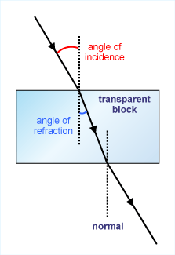**Mandatory Experiments**

1. As in diagram, plus a ray box and protractor.
2. The angle of incidence and the angle of refraction.
3. By using the formula n = sin i ÷ sin r.
4. To increase the accuracy of the results.
5. See diagram. Also include a protractor and raybox.
6. Draw the incident ray going in, the emergent ray coming out, then remove the block and join the two lines. This represents the refracted ray.
7. By measuring the angle between the normal and the refracted ray using a protractor.

|  |  |  |  |  |
| --- | --- | --- | --- | --- |
| angle of incidence i | angle of refraction r | sin i | sin r | sin i/sin r |
| 30o | 19o | 0.500 | 0.326 | 1.53 |
| 45o | 28o | 0.707 | 0.469 | 1.51 |
| 65o | 37o | 0.906 | 0.602 | 1.50 |

1. In each case sin i/sin r is (approximately) constant; therefore this verifies Snell’s Law.
2. Diagram to show:

A target medium e.g. glass block

Incident ray (from ray box)

Perpendicular / normal and refracted ray

Label angles *i* and *r*

1. Correct sin *i* and sin *r* values for six points

|  |  |  |  |  |  |  |  |
| --- | --- | --- | --- | --- | --- | --- | --- |
| sin *i* | 0.500 | 0.643 | 0.766 | 0.819 | 0.866 | 0.906 | 0.939 |
| sin *r* | 0.325 | 0.438 | 0.500 | 0.544 | 0.588 | 0.615 | 0.643 |

Label axes correctly on graph paper

Plot six points correctly

Straight line showing good distribution

1. A straight line through the origin shows that sin *i* is proportional to sin *r*
2. Correct slope method

(*n* = ) 1.41 [range: 1.38 – 1.52]

1. To reduce the (percentage) error

Elaboration e.g. difficult to measure /read angles, *r* < *i* , etc.

1. See diagram, plus ray-box.

Mark the position of the incident and exit rays and also the outline of the block.

Remove the block then measure the angle between the refracted ray and the normal using a protractor.

|  |  |  |  |  |  |  |
| --- | --- | --- | --- | --- | --- | --- |
| sin i | 0.34 | 0.50 | 0.64 | 0.77 | 0.87 | 0.94 |
| sin r | 0.24 | 0.33 | 0.44 | 0.50 | 0.59 | 0.64 |

1. Refractive index = slope = y2 – y1 / x2 – x1  n = 1.49
2. There would be a greater percentage error associated with measuring smaller angles.

**Common Test errors**

**State the laws of refraction of light**

Don’t use the word “reflection” in your answer

**What is meant by the refractive index of a material?**

Include the phrase “as light travels from a vacuum into that medium”

**Explain how a signal is transmitted along an optical fibre.**

Give three separate points

**Experiment to verify Snell’s law**

**Using the recorded data, draw a suitable graph**

It must be a graph of *sin i* against *sin r* {not i and r}

**Using your graph, find the refractive index**

You must calculate the slope of the graph by using two points which are clearly marked on the graph {so you can’t take points from the table unless they also happen to be on the line of best fit which you have drawn}